Chapter 5 Multivariate Probability Distributions

* 5.2 Bivariate and Multivariate Probability Distributions

*Let Y1 and Y2 be discrete random variables. The* ***joint (or bivariate) probability (mass)*** *function for Y1 and Y2 is given by*

*p(y1,y2)= P(Y1 = y1,Y2 = y2), −∞< y1 <∞,−∞< y2 <∞*

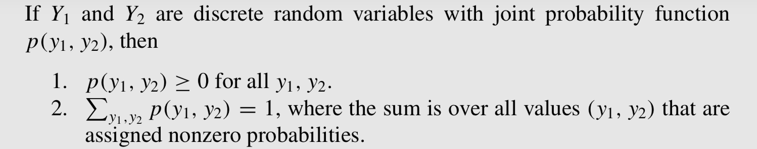

*For random variables Y1 and Y2, the* ***joint (or bivariate) distribution function*** *F(y1, y2):*

*F(y1,y2)= P(Y1 ≤ y1,Y2 ≤ y2), −∞< y1 <∞,−∞< y2 <∞.*

*Let Y1 and Y2 be continuous random variables with joint distribution function F(y1, y2). If there exists a nonnegative function f (y1, y2), such that*

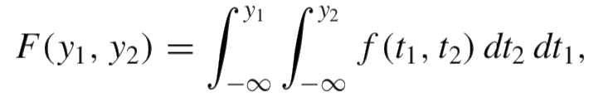

*for all −∞< y1 <∞,−∞< y2 <∞,then Y1 and Y2 are said to be* ***jointly continuous random variables****. The function f (y1, y2) is called the* ***joint probability density function****.*

<Theorem>

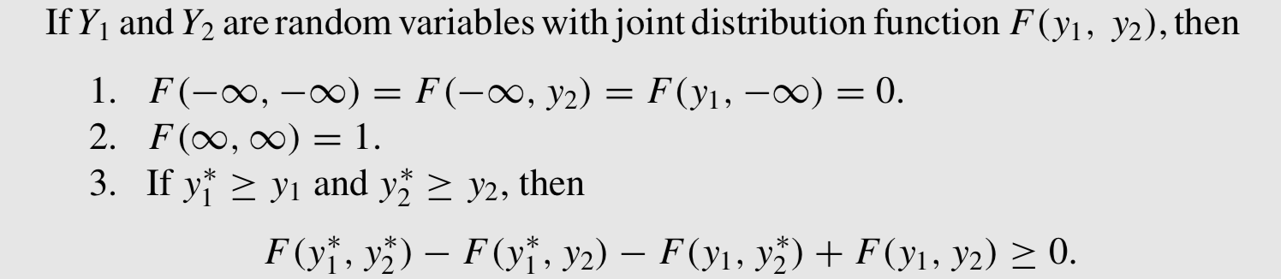

<Theorem>

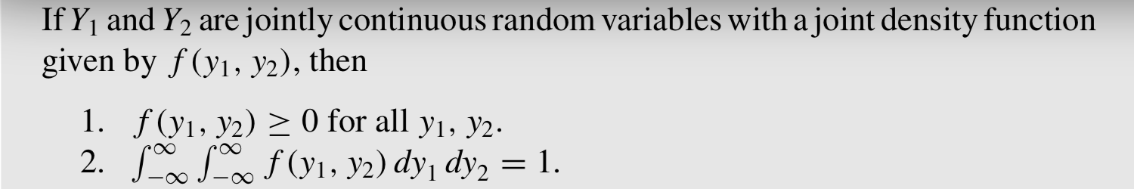

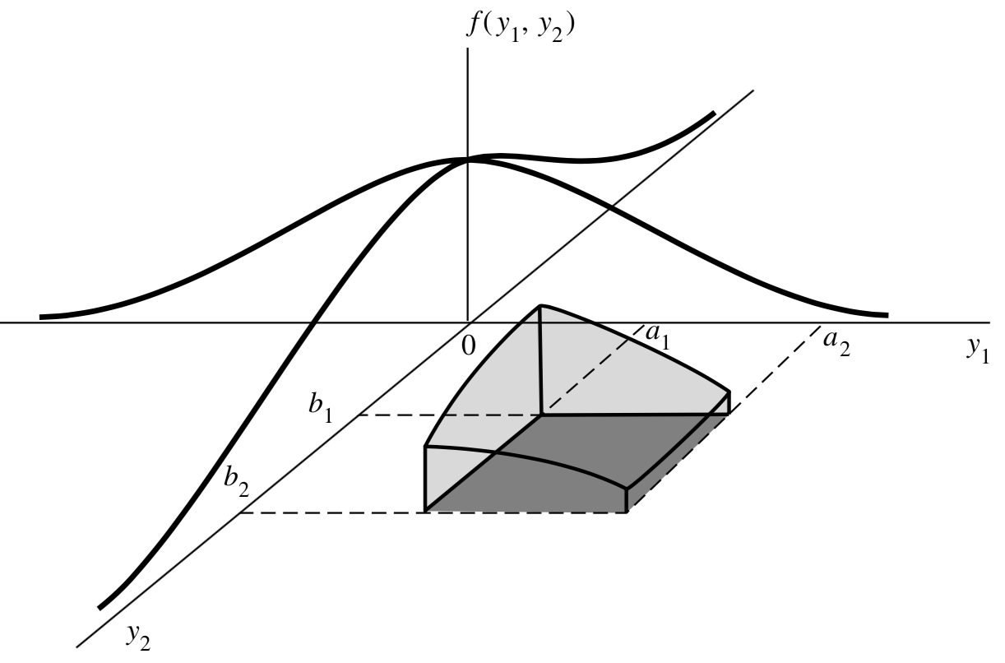

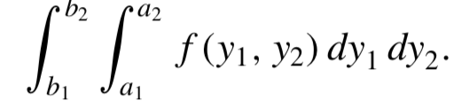P (a1 ≤ Y1 ≤ a2 , b1 ≤ Y2 ≤ b2)

=

* 5.3 Marginal and Conditional Probability Distributions

*Let Y1 and Y2 be jointly discrete random variables with probability function p(y1, y2). Then* ***the marginal probability functions*** *of Y1 and Y2, respectively, are given by*

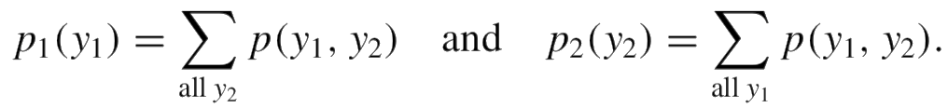

*b Let Y1 and Y2 be jointly continuous random variables with joint density function f (y1, y2).* ***Then the marginal density functions*** *of Y1 and Y2, respectively, are given by*



The multiplicative law gives the probability of the intersection A ∩ B as P(A ∩ B) = P(A)P(B|A).

*If Y1 and Y2 are jointly discrete random variables with joint probability function p(y1, y2) and marginal probability functions p1(y1) and p2(y2), respectively, then the* ***conditional discrete probability function*** *of Y1 given Y2 is*

**

*provided that p2(y2) > 0.*

Note that p(y1|y2) is undefined if p2(y2) = 0.

*If Y1 and Y2 are jointly continuous random variables with joint density function f (y1, y2), then the* ***conditional distribution function*** *of Y1 given Y2 = y2 is*

*F(y1|y2) = P(Y1 ≤ y1|Y2 = y2)*

*Let Y1 and Y2 be jointly continuous random variables with joint density f ( y1 , y2 ) and marginal densities f1(y1) and f2(y2), respectively. For any y2 such that f2(y2) > 0, the* ***conditional density of Y1*** *given Y2 = y2 is given by*

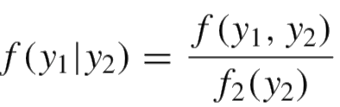

Note that the conditional density f ( y1 | y2 ) is undefined for all y2 such that f2(y2) = 0.

* 5.4 Independent Random Variables

*Let Y1 have distribution function F1(y1), Y2 have distribution function F2(y2), and Y1 and Y2 have joint distribution function F(y1, y2). Then Y1 and Y2 are said to be* ***independent*** *if and only if*

*F(y1, y2) = F1(y1)F2(y2)*

*for every pair of real numbers (y1, y2).*

*If Y1 and Y2 are not independent, they are said to be* ***dependent****.*

<Theorem>

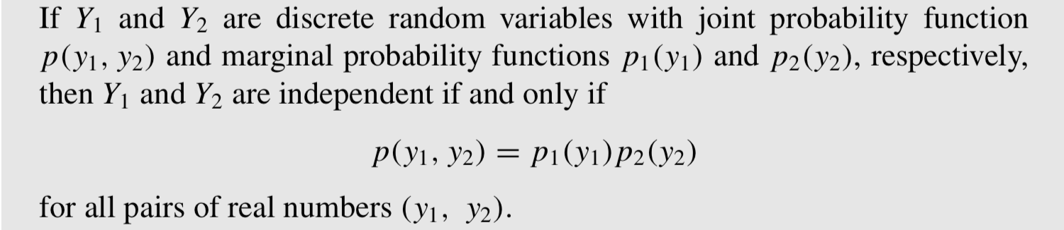

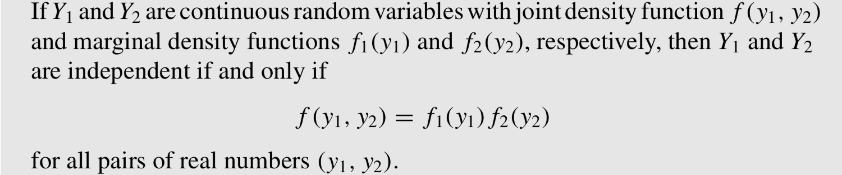

<Theorem>

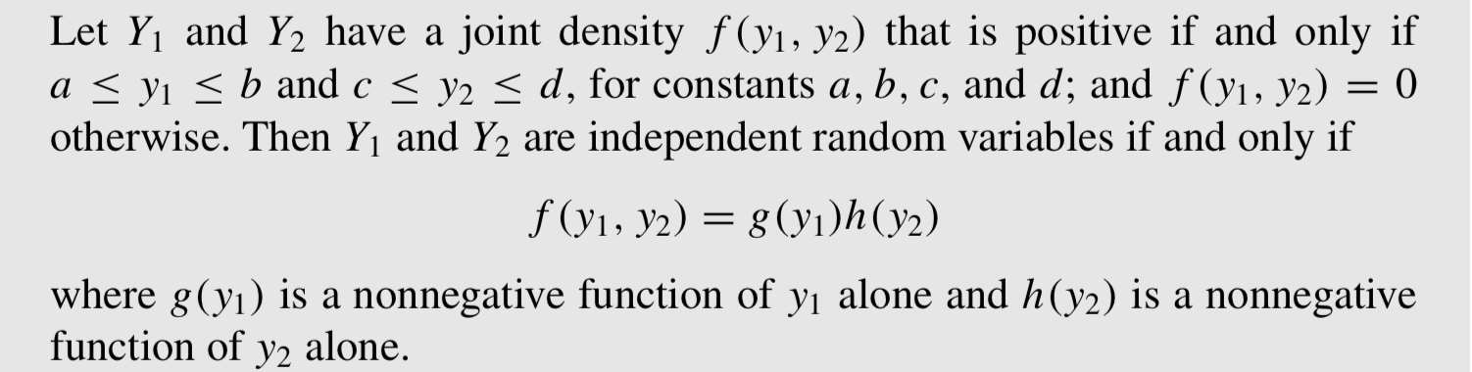

Ex. Let Y1 and Y2 have a joint density given by

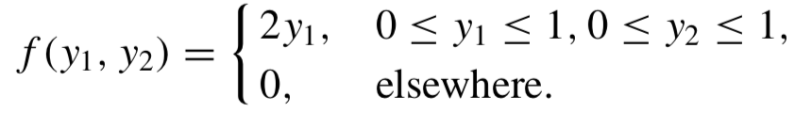

Are Y1 and Y2 independent variables?

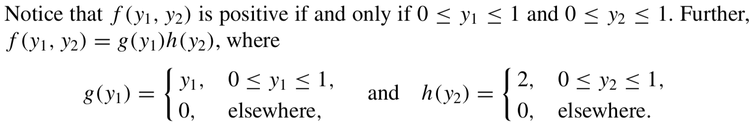



* 5.5 The Expected Value of a Function of Random Variables

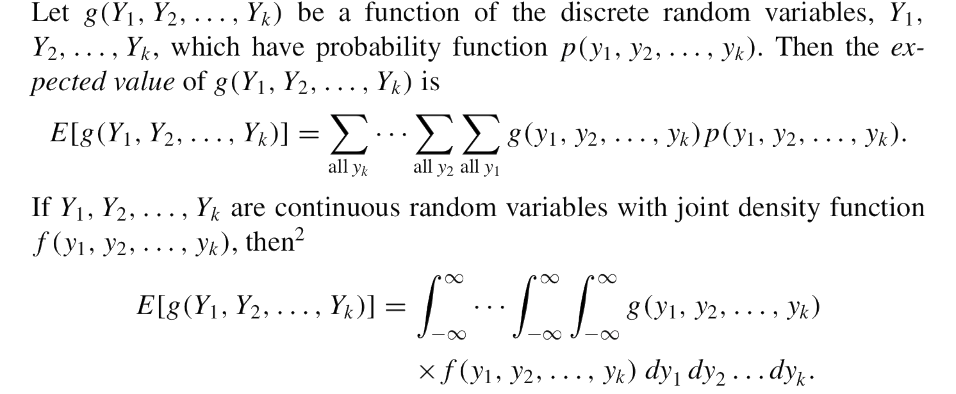

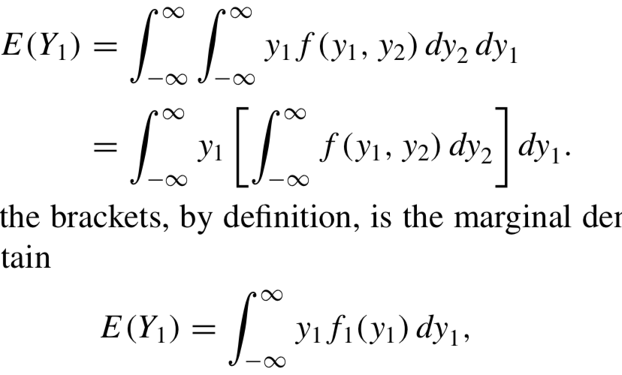Note that

* 5.6 Special Theorems

<Theorem 1>



<Theorem 2>

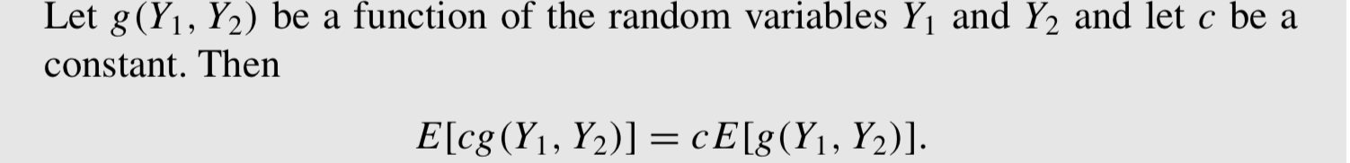

<Theorem 3>

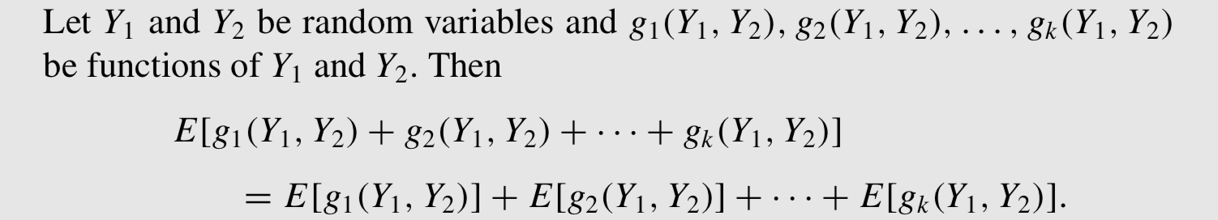

<Theorem 4>

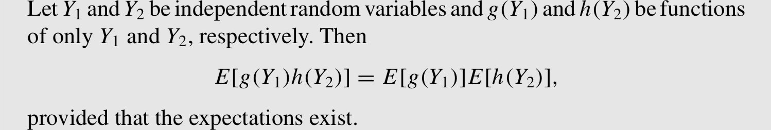

* 5.7 The Covariance of Two Random Variables

*If Y1 and Y2 are random variables with means μ1 and μ2, respectively, the* ***covariance*** *of Y1 and Y2 is*

*Cov(Y1, Y2) = E [(Y1 − μ1)(Y2 − μ2)] .*

The larger the absolute value of the covariance of Y1 and Y2, the greater the linear dependence between Y1 and Y2. Positive values indicate that Y1 increases as Y2 increases; negative values indicate that Y1 decreases as Y2 increases. A zero value of the covariance indicates that the variables are **uncorrelated** and that there is no linear dependence between Y1 and Y2.

But the covariance depends on the scale of measurement. This problem can be eliminated by standardizing its value and using the **correlation coefficient, ρ**

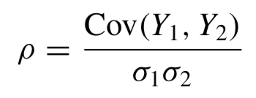

Note that −1 ≤ ρ ≤ 1.

<Theorem 1>



<Theorem 2>

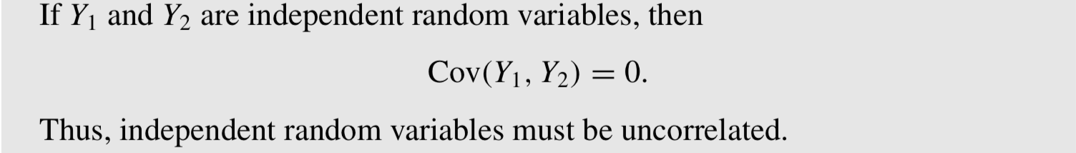

Note that the converse of Theorem 2 is NOT true.

Ex. Let Y1 and Y2 be discrete random variables with joint probability distribution as shown in Table 5.3. Show that Y1 and Y2 are dependent but have zero covariance.

Calculation of marginal probabilities yields p1 (−1) = p1 (1) = 5/16 = p2 (−1) = p2(1), and p1(0) = 6/16 = p2(0). The value p(0, 0) = 0 in the center cell stands out. Obviously, p(0,0) ≠ p1(0)p2(0), and this is sufficient to show that Y1 and Y2 are dependent.

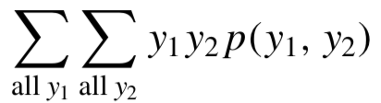Again looking at the marginal probabilities, we see that E(Y1) = E(Y2) = 0.

Also E(Y1Y2)= =0.

Thus Cov(Y1, Y2) = E(Y1Y2) − E(Y1)E(Y2) = 0 − 0(0) = 0.

If the covariance of two random variables is zero, the variables **need not** be independent

* 5.8 The Expected Value and Variance of Linear Functions of Random Variables

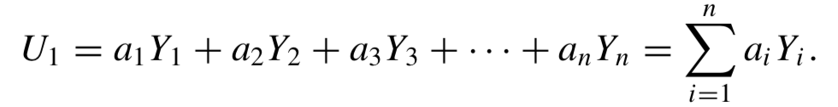

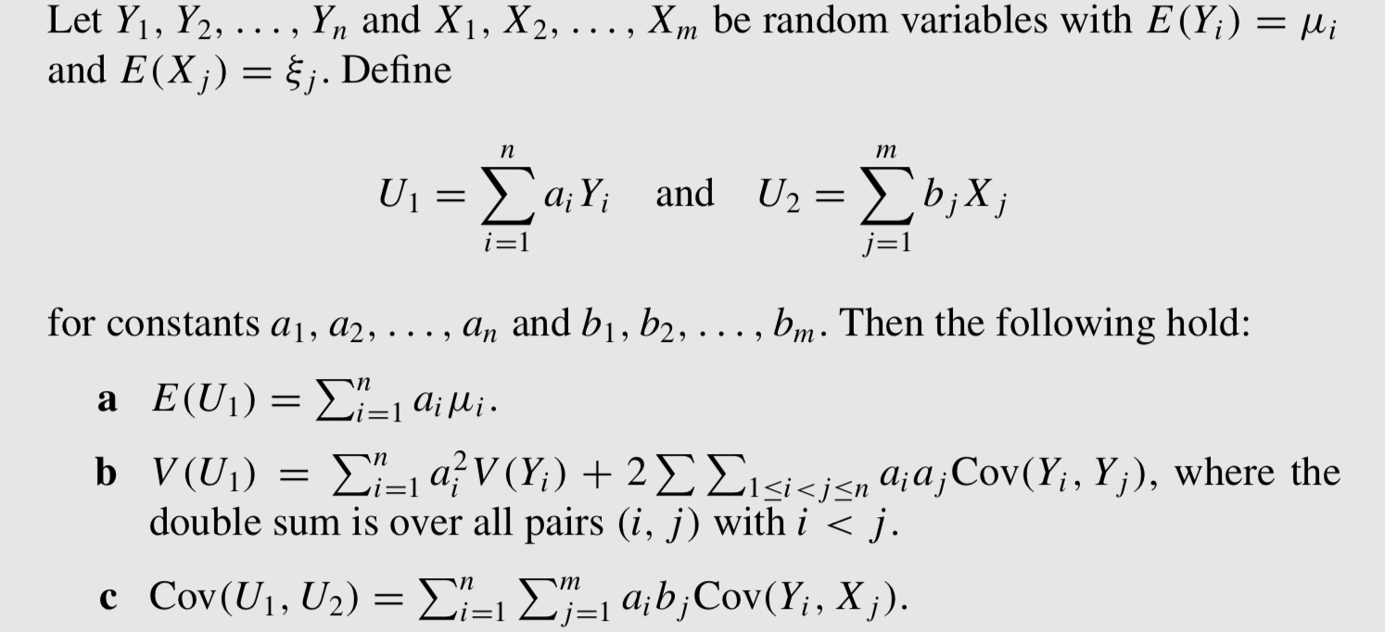

Ex. The number of defectives Y in a sample of n = 10 items selected from a manufacturing process follows a binomial probability distribution. An estimator of the fraction defective in the lot is the random variable pˆ = Y/n. Find the expected value and variance of pˆ .

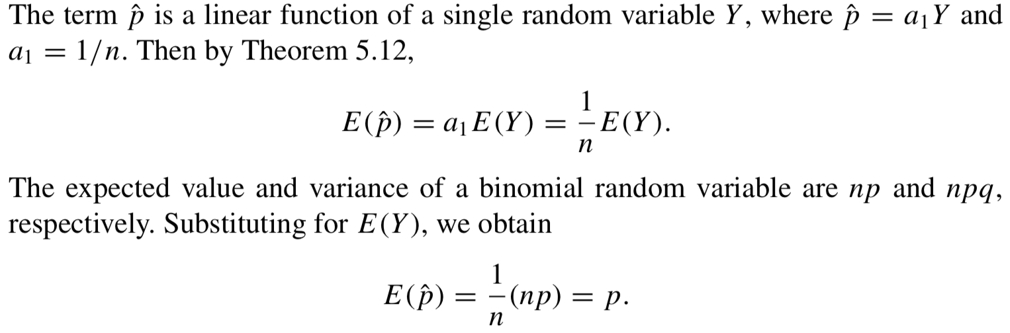

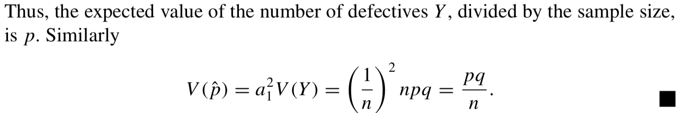

* 5.9 The Multinomial Probability Distribution

*A* ***multinomial experiment*** *possesses the following properties:*

*1. The experiment consists of n identical trials.*

*2. The outcome of each trial falls into one of k classes or cells.*

*3. The probability that the outcome of a single trial falls into cell i , is pi , i = 1,2,...,k and remains the same from trial to trial. Notice that p1+p2+p3+···+pk =1.*

*4. The trials are independent.*

*5. The random variables of interest are Y1 , Y2 , . . . , Yk , where Yi equals the number of trials for which the outcome falls into cell i. Notice that Y1 +Y2 +Y3 +···+Yk =n.*

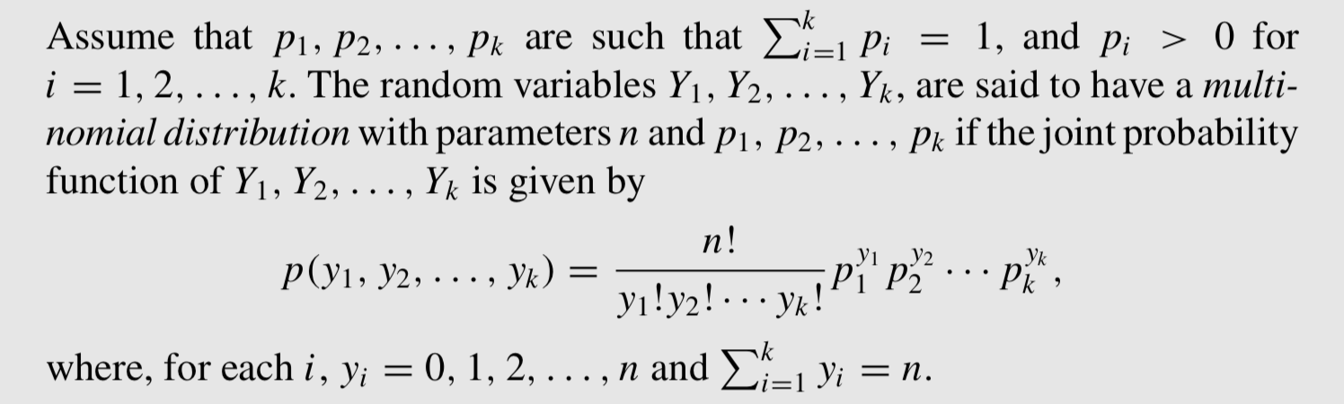

Ex. According to recent census figures, the proportions of adults (persons over 18 years of age) in the United States associated with five age categories are as given in the following table. If these figures are accurate and five adults are randomly sampled, find the probability sample contains one person between the ages of 18 and 24, two between the 25 and 34, and two between the ages of 45 and 64.

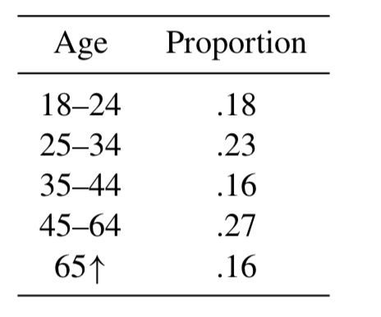 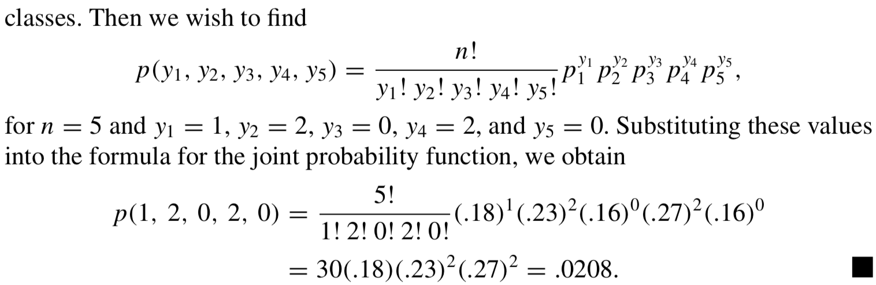

<Theorem>

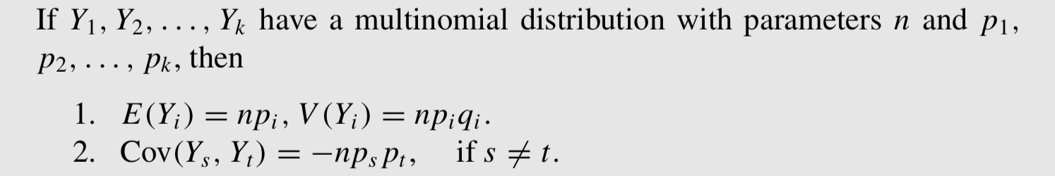

* 5.10 The Bivariate Normal Distribution

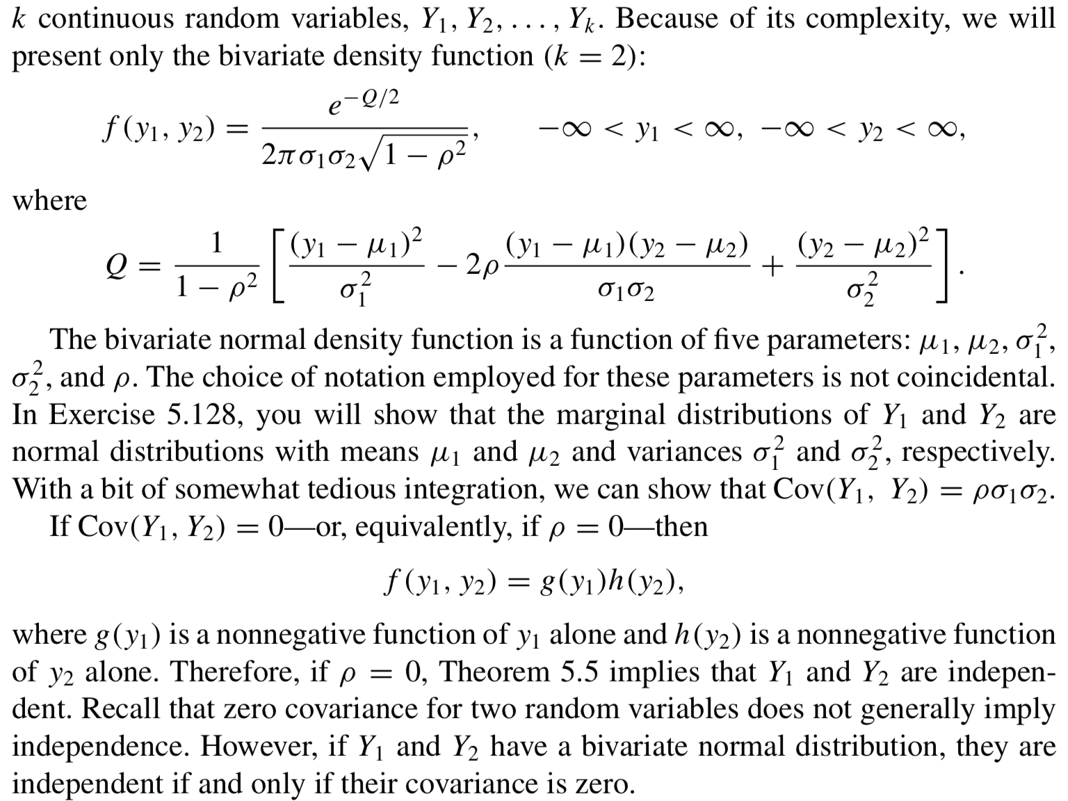

* 5.11 Conditional Expectations

*If Y1 and Y2 are any two random variables, the* ***conditional expectation*** *of g(Y1), given that Y2 = y2, is defined to be*

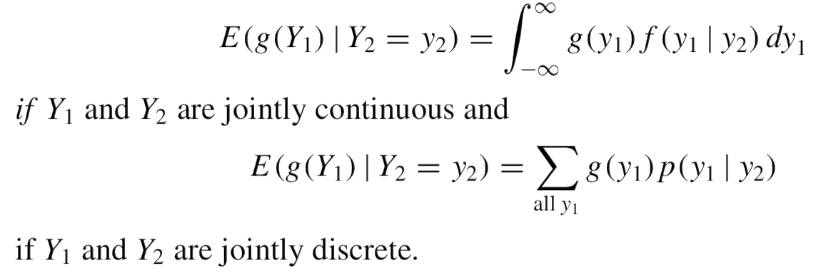

<Theorem>

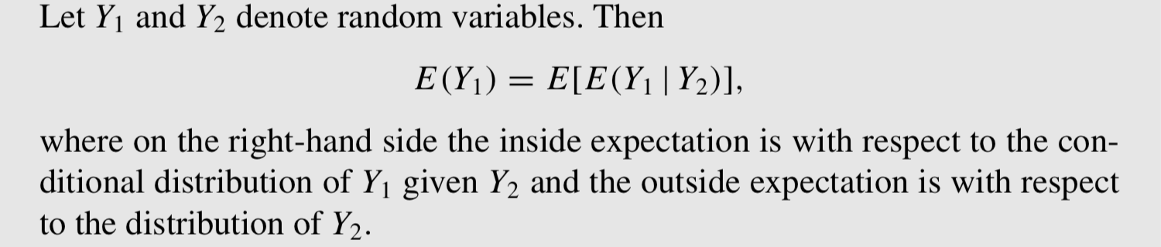

<Theorem>

